1. You can visit <https://www.arihantcapital.com/> on our official website to know correct information.

This field is invalid as it is already on the main website pop-up

1. You may contact on our support Desk for more information on 07314217003
2. Direct Tab in the note tab to contact directly to the customer care section
3. The barcode should be placed on top right or midpoint of the empty space as in desk mode it covers Start Investing Frame which makes it less attractive or more better UI complexion

Or Directly stick barcode in the midpoint with the title download app for mob as it is not available for Pc

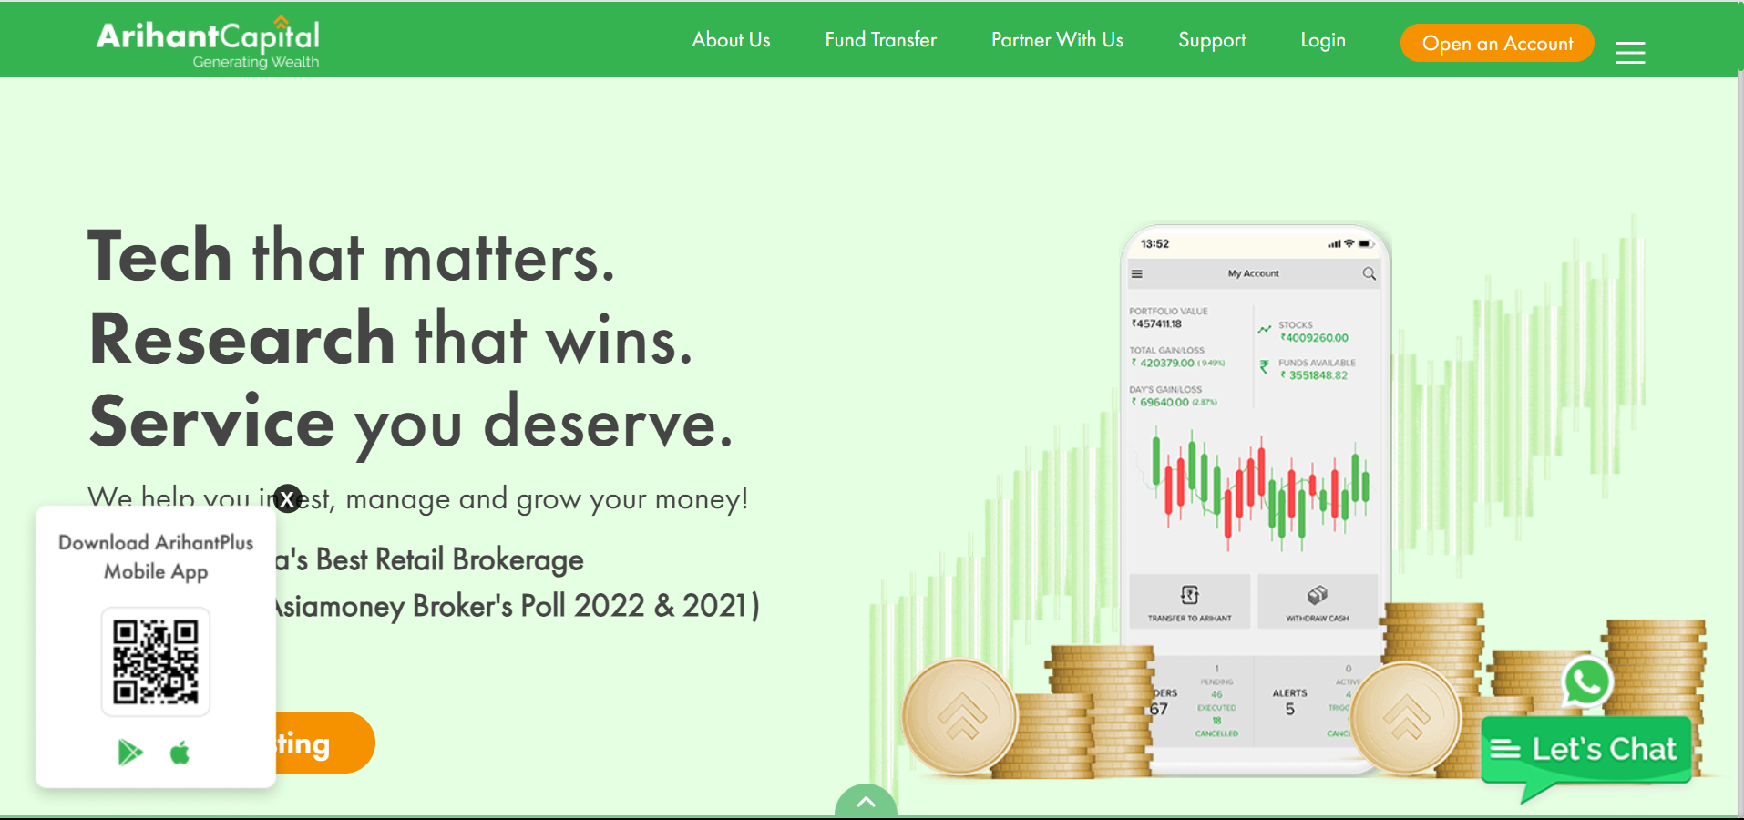

5.Need more highlight on social media area

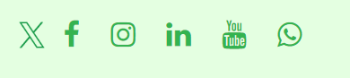

1. For pc whats app sec is not compatible it doesn’t revert message automatically

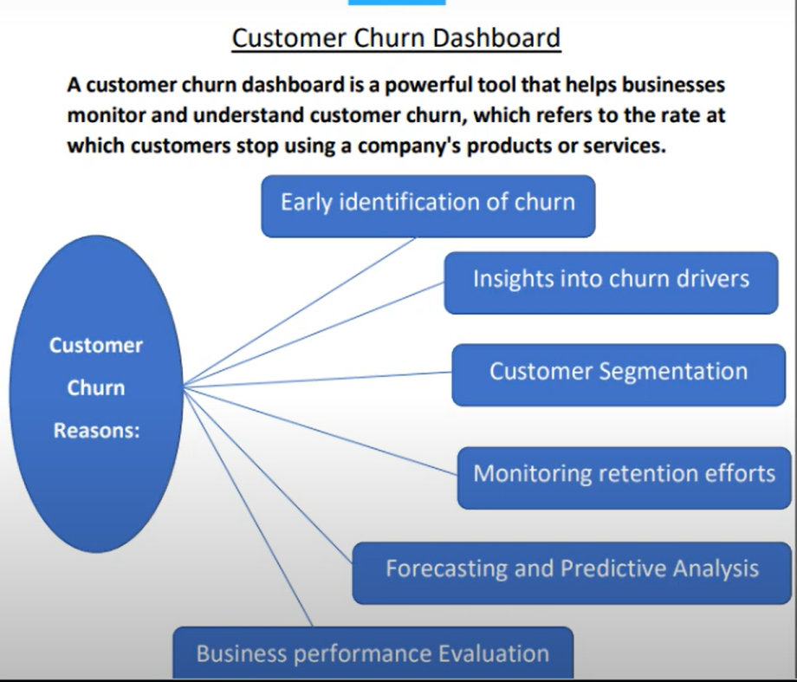

1. Long and time consuming process decreases the interest of the customer

